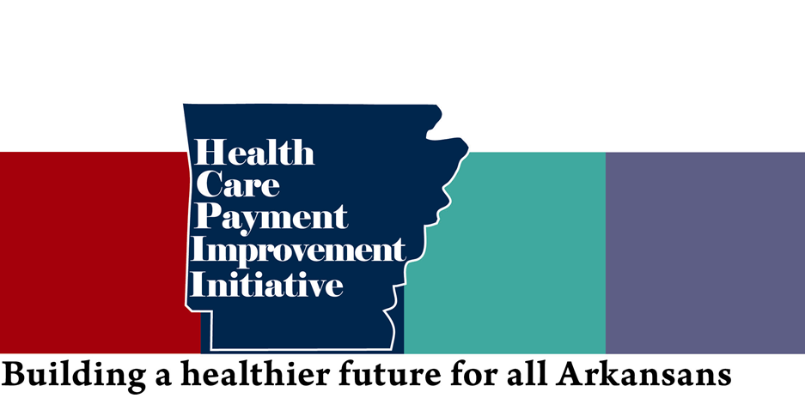
Arkansas Medicaid PCMH 2017
Patient Centered Medical Home
PROGRAM PARTICIPATION
 | Practices | % Enrolled | PCPs | % Enrolled | Beneficiaries | % Enrolled
2014 | 123 / 259 | 47% | 659 / 1074 | 61% | 295K/386k | 76%
2015 | 142 / 250 | 57% | 780 / 1074 | 73% | 317k/386k | 80%
2016 | 179 / 250 | 72% | 878 / 1010 | 87% | 330k/414k | 80%
2017 | 192 / 252 | 76% | 928 / 1068 | 87% | 356k/420k | 85%

PRACTICE SUPPORT

CARE COORDINATION PAYMENTS (PBPMs)
- On average $4 per member per month but varies from $1-$30.
- Risk Adjusted using the John Hopkins grouper; it takes into account the four primary diagnosis of the patient as well as demographic factors.
- These activities closely align with the CPC + Program, NCQA, and other payer requirements to alleviate the burden on providers.
- High Success rate, since inception of the program, only nine practices (five in 2016 and four in 2017) have been suspended for not meeting these requirements.
- Loss of PBPMs is considered the current downside risk of participating in PCMH.
- Practices input information into the AHIN portal.
- Activities are validated twice per year via Quality assurance team (AFMC), validation visits last approximately 1-1.5 hours.
- Care plan submission is done via the AHIN portal, practices upload PDF and information is securely sent to AFMC QA
- Practices must meet activity requirements in order to receive PBPMs

PRACTICE TRANSFORMATION
DMS funded Practice Transformation coaching is available for up to 24 months upon initial enrollment. Coaches assist with care plan development, updating workflows and processes, interpreting data and reports, and they provide additional educational resources.

SHARED SAVINGS

ELIGIBILITY

PCMHs must meet the following to receive shared saving incentive bonus
- Meet practice support activities
- Meet 5000 beneficiary requirement either
- Standalone
- Voluntarily Pool with friends
- Default pool
- Reduce total cost of care by at least 2% at pool or standalone level
- Meet targets for at least 2/3 of Quality Metrics
- Metric targets are set a rate no higher than the average performance of the previous year. 50Th percentile
- Metrics require 25 min attributed beneficiaries for PCMHs to be held accountable
- Most are claims based with the exception of 14,15,16, and 17 which are eCQMs (Electronically pulled from EHR reports)
- National measures adapted to fit within Arkansas population, revisions are made based on recommendations made by providers, multipayer group, and partners such as AMS, AAFP, and AAP.

SHARED SAVINGS INCENTIVE PAYMENTS

- Arkansas is one of the few states that has been able to provide shared savings incentive payments.
- Payments are risk and time adjusted
- $8.8 million was paid to 30 PCMHs for 2014 performance
- $12.8 million was paid to 53 PCMHs for 2015 performance.
- PCMHs can get shared savings in one of two ways
- Absolute Method
- 50% of savings
- Total cost of care (TCOC) is below medium threshold
- Relative Method
- TCOC is lower than the PCMH’s benchmark(previous performance)
- Savings vary from 10-50% depending on benchmark being below or above medium or high thresholds.

PCMH (Medicaid) vs CPC+ (Medicare)
PCMH closely aligns with CPC + requirements however requirements for CPC+ are more rigorous. The majority of activities required for PCMH are also required to be in good standing with CPC +. The only exceptions are:

- Enrollment in AR Prescription Monitoring program
- PCMHs must implement a process to deliver immunization to both the pediatric and adult population
- Process for e-prescribing
- Health literacy
However, practices enrolled in CPC+ could use some the above requirements to fulfill population health requirements for CPC+.

2015 Results CPC (Medicare) vs AR PCMH (Medicaid)

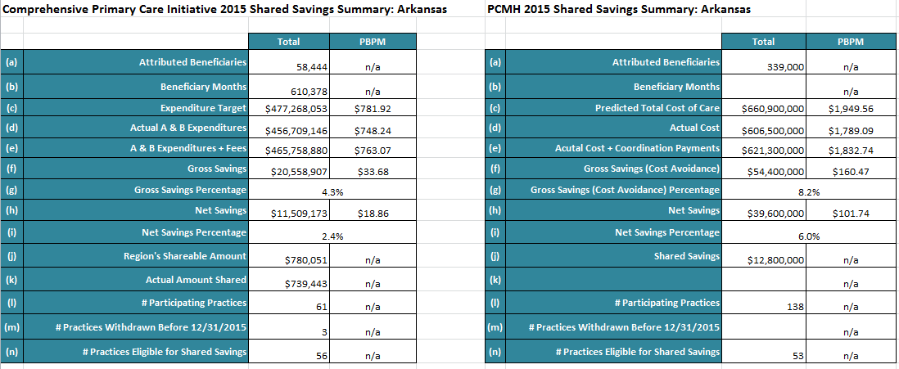

PCMH Results

Cost Reduction
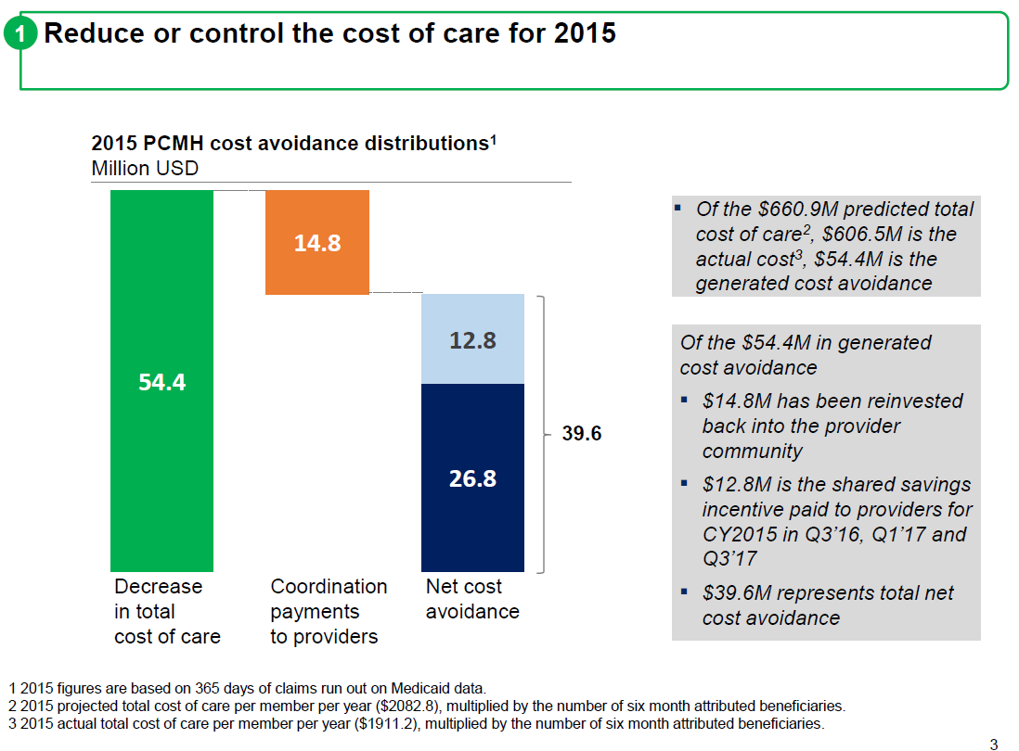

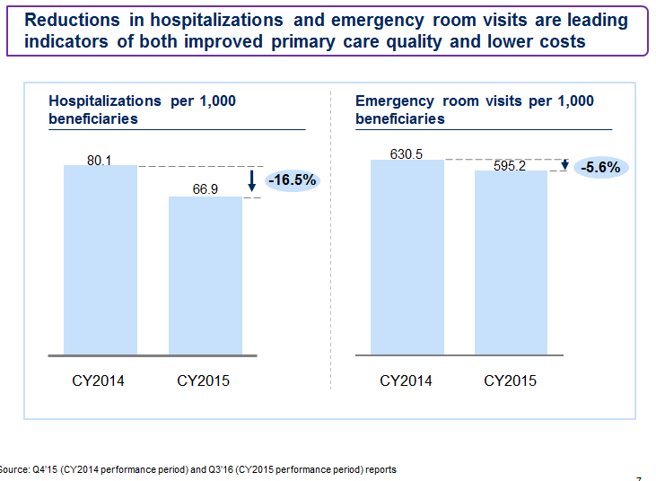

PCMH 2.0

- Increase provider participation
- Reduce the number of required beneficiaries from 300 to 150
- Add additional pool for smaller practices to participate
- Medical Neighborhood
- Utilize Episodes of Care data to inform primary care physicians of specialist’s cost and quality outcomes.
- Behavior health integration
- PASSE will assume full risk for tier 2 and tier 3 BH/DD beneficiaries starting in 2019
- Policy has been tweaked to allow for co-location of BH services under PCMHs (webinar taking place on 09/08 to educate providers)
- Provide PCMHs with informational Medical Neighborhood reports on Quality and Cost of behavior health services. The first report should roll out in 2018 and will focus on ADHD and ODD.
- Add minimal risk to PCMH program
- Require failing PCMHs to improve performance prior to re-enrolling
- Update Cost Thresholds (required by SPA)
- Actuarial analysis is being completed (expected delivery date is 06/30/2017)
- Benchmarks will be updated to most recent data
- Enhanced data analytical capacity with MMIS
- Opioids usage rate report

These changes closely align with the task force recommendations

2018 ACTIVITIES TRACKED FOR PRACTICE SUPPORT (PBPMs)

Activity
3 Month
6 Month
12 Month

Identify top 10% of high-priority patients (Auto feature avail.)

Provide 24/7 access to care

Document approach to expanding access to same-day appointments

Capacity to receive direct e-messaging from the patients: Describe method of e-messaging used.

Enrollment in the Arkansas Prescription Monitoring Program (PMP): All PCPs must enroll in PMP. Report method(s) used to monitor controlled substance prescriptions using PMP.

Care Plans for High Priority Beneficiaries: 80% HPB
Join SHARE or participate in a network that delivers hospital discharge information to practice within 48 hours
Patient Literacy Assessment Tool: Choose any health literacy tool and administer the screening to at least 50 beneficiaries (enrolled in the PCMH program) or their caregivers.
Care Instructions for HPB: Create and share with the patient an after-visit summary of the patient’s visit. Include diagnosis, medication list, tests and results (if available), referrals (if applicable), and follow up instructions.
Medication Management: Describe the practices EHR reconciliation process. Document updates to active medication list in EHR for HPB
Ability to receive Patient Feedback: Indicate method used to receive patient feedback and describe how feedback is used to make improvements.
Childhood/Adult Vaccination Practice Strategy
Incorporate e-prescribing into practice workflows
6 Month
3 Month
10-day follow-up after an acute inpatient hospital stay. Target 40%
12 Month
Activity
2018 METRICS TRACKED FOR SHARED SAVINGS

2018 Metric Targets

- Claims-based 2018 Quality Metric targets are set at a level no higher than the average performance of the shared savings entities in 2016.

- The quality metrics are assessed only if the shared savings entity has at least the minimum number of attributed beneficiaries in the category described for the majority of the performance period.

- New metrics will roll out as informational for at least one year prior to making them a requirement.

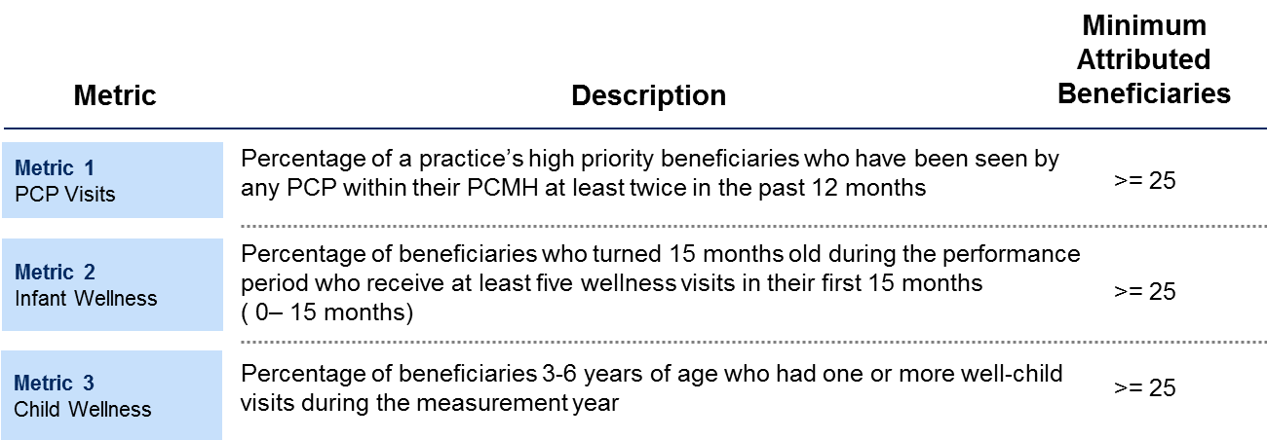
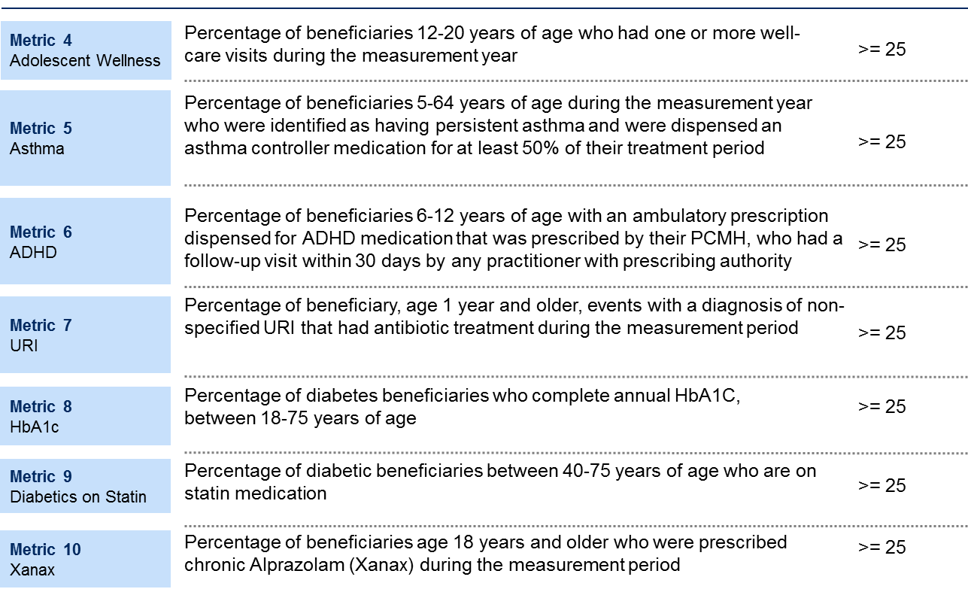
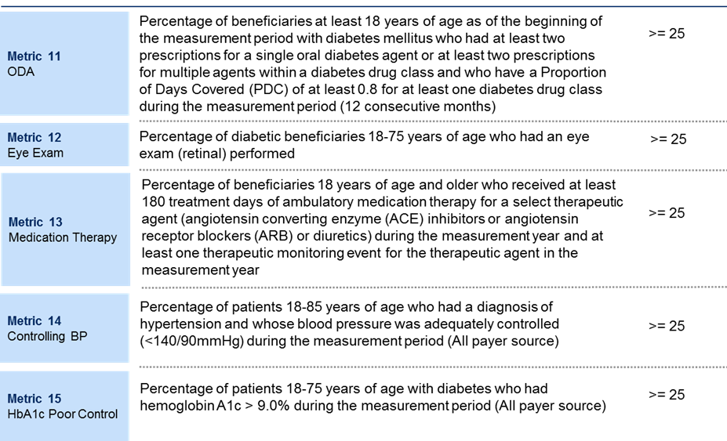
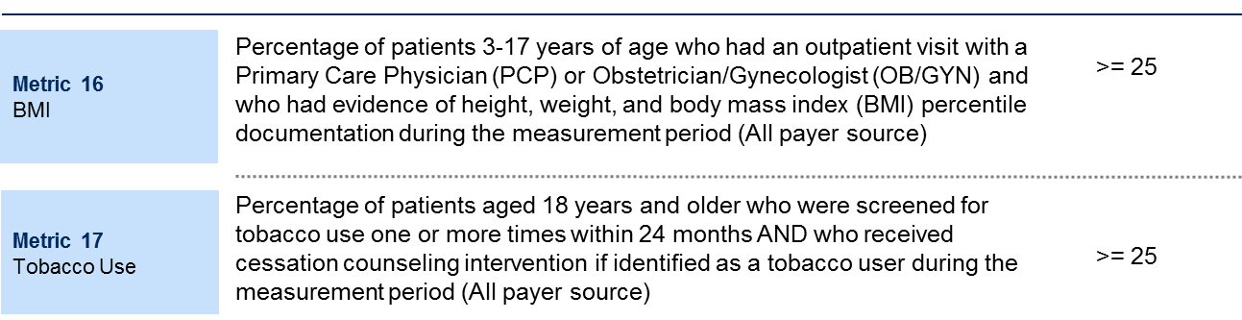

Example of how Metric Targets are set
